UNIT V
Protection and Safety of Electrical Systems:
Introduction to domestic wiring, Fuse, MCB, ELCB and Relay.
Necessity of earthing, difference between earthing and grounding and types of grounding.
Electric shocks, hazards and safety precautions.
NOTES:
Protection
- Fuses
- Circuit Breakers
  - MCB
  - ELCB
- Relays

Electrical Fuse
A fuse is a part of the circuit which consists of a conductor which melts easily and breaks the connection when current exceeds the predetermined value. An electrical fuse is the weakest part of an electrical circuit which breaks when more than predetermined current flows through it.

Fuse Wire
The function of fuse wire is to carry the normal current without excessive heating but more than normal current when passes through fuse wire, it rapidly heats up and melts.

Materials used for Fuse Wires
The materials used for fuse wires are mainly tin, lead, zinc, silver, antimony, copper, aluminum etc.

Fuse Wire Rating
The melting point and specific resistance of different metals used for fuse wire

Some Important Terms

Minimum Fusing Current
It is minimum value of current due to which fuse melts.

Current Rating of Fuse
It is maximum value of current due to which fuse does not get melt.

Fusing Factor
This is the ratio of minimum fusing current and current rating of fuse. Therefore, fusing factor = Minimum fusing current or current rating of the fuse. The value of fusing factor is always more than 1.

Prospective Current in Fuse
Before melting, the fuse element has to carry the short circuit current through it.The prospective current is defined as the value of current which would flow through the fuse immediately after a short circuit occurs in the network.

Melting Time of Fuse or Pre-arcing Time of Fuse
This is the time taken by a fuse wire to get broken by melting. It gets counted from the instant; the overcurrent starts flowing through the fuse, to the instant when fuse wire gets just broken by melting.

Arcing Time of Fuse
After breaking of fuse wire there will be an arcing between both melted tips of the wire which will be extinguished at the current zero. The time accounted from the instant of arc initiated to the instant of the arc gets extinguished is known as arcing time of fuse.

Operating Time of Fuse
Whenever overrated current starts to flow through a fuse wire, it takes time to be melted and disconnected, and just after that the arcing stars between the melted tips of the fuse wire, which finally gets extinguished. The operating time of fuse is the time gap between the instant when the overrated current starts to flow through the fuse and the instant when the arc in fuse finally gets extinguished. That means operating time of fuse = melting time + arcing time.

Current Carrying Capacity of Fuse Wire
Current carrying capacity of a fuse wire depends upon numbers of factors like, material used, the dimension of wire, i.e., diameter and length, size and shape of terminals used to connect it, and the surrounding.

Fuse Law
Fuse law determines the current carrying capacity of a fuse wire. We can establish the law in the following way. At steady state condition that is when fuse carries normal current without increasing its temperature to the melting limit. That means at this steady state condition, heat generated due to the current through fuse wire is equal to heat dissipated from it. Heat generated = I²R. Where, R is the resistance of the fuse wire.
Types of Fuses:

Rewirable or Kit Kat Fuse Unit
Rewirable or Kit Kat Fuse Unit is most commonly used fuse in our day to day life. This fuse has mainly two parts. The unit in which the incoming and outgoing line or phase wire connected permanently is known as fuse base. The removable part which holds the fuse wire and fits into the base is known as fuse carrier. The fuse carrier is also known as cutout.

Cartridge Fuse
In cartridge fuse the fuse wire is enclosed in a transparent glass tube or bulb, the whole unit is sealed off. In case the fuse blows, it is to be replaced by new one as the cartridge fusecannot be rewired due to its sealing.

Lead - tin Alloy Fuse Wire or Eutectic Alloy Fuse Wire
For small value of current interruption lead – tin alloy fuse wire has been used in past. The most preferred lead – tin alloy for fuse wire containing 37% lead and 63% tin. This alloy fuse wire is also known as known as Eutectic Alloy Fuse Wire. This type of alloy has some specific characteristics due to which this is preferred as fuse wire.
- It has the high brinnel hardness and has less tendency to spread over.
- The alloy metal is quite homogeneous.
- If the fusing characteristics of eutectic alloy and other composition of alloys is studied there is only one arrest point in eutectic alloy as compared to two other types of alloys.

HRC Fuse or High Rupturing Capacity Fuse
HRC fuse or high rupturing capacity fuse- In that type of fuse, the fuse wire or element can carry short circuit heavy current for a known time period. During this time if the fault gets removed, then it does not blow off. Otherwise, it blows off or melts. The enclosure of HRC fuse is either of glass or some other chemical compound. This enclosure is sufficiently airtight to avoid the effect of the atmosphere on the fuse materials. The ceramic enclosure having metal end cap at both heads, to which fusible silver wire gets welded. There is a space within the enclosure, surrounding the fuse wire or fuse element, completely packed with a filling powder. This type of fuse is reliable and has inverse time characteristic, that means if the fault current is high then rupture time is less, and if fault current is not so high, then rupture-time is long.
Circuit Breakers
All fuses need to be replaced with MCB for better safety and control when they have done their job in the past. Unlike a fuse, an MCB operates as automatic switch that opens in the event of excessive current flowing through the circuit and once the circuit returns to normal, it can be reclosed without any manual replacement. MCBs are used primarily as an alternative to the fuse switch in most of the circuits. A wide variety of MCBs have been in use nowadays with breaking capacity of 10kA to 16 kA, in all areas of domestic, commercial and industrial applications as a reliable means of protection

What is Miniature Circuit Breaker (MCB)?

An MCB or miniature circuit breaker is an electromagnetic device that represents complete enclosure in a molded insulating material. The main function of an MCB is to switch the circuit, i.e., to open the circuit (which has been connected to it) automatically when the current passing through it (MCB) exceeds the value for which it is set. It can be manually switched ON and OFF as similar to normal switch if necessary.
MCBs are of time delay tripping devices, to which the magnitude of overcurrent controls the operating time. This means, these get operated whenever overload exist long enough to create a danger to the circuit being protected. Therefore, MCBs doesn’t respond to transient loads such as switches surges and motor starting currents. Generally, these are designed to operate at less than 2.5 milliseconds during short circuit faults and 2 seconds to 2 minutes in case of overloads (depending on the level of current).

Construction of MCB
An MCB embodies complete enclosure in a molded insulating material. This provides mechanically strong and insulated housing. The switching system consists of a fixed and a moving contact to which incoming and outgoing wires are connected. The metal or current carrying parts are made up of electrolytic copper or silver alloy depending on the rating of the circuit breaker.
As the contacts are separated in the event of an overload or short circuit situation, an electric arc is formed. All modern MCBs are designed to handle arc interruption process where arc energy extraction and its cooling are provided by metallic arc splitter plates. These plates are held in a proper position by an insulating material. Also, arc runner is provided to force the arc that is produced between the main contacts.
The operating mechanism consists of both magnetic tripping and thermal tripping arrangements.
The magnetic tripping arrangement essentially consists of a composite magnetic system that has a spring loaded dashpot with a magnetic slug in a silicon fluid, and a normal magnetic trip. A current carrying coil in the trip arrangement moves the slug against spring towards fixed pole piece. So the magnetic pull is developed on the trip liver when there is a sufficient magnetic field produced by the coil. In case of short circuits or heavy overloads, strong magnetic field produced by the coils (Solenoid) is sufficient to attract the armature of trip liver irrespective of the position of slug in the dashpot.
The thermal tripping arrangement consists of a bimetallic strip around which a heater coil is wounded to create heat depending on the flow of current. The heater design can be either direct where current is passed through bimetal strip which effect part of electric circuit or indirect where a coil of current carrying conductor is wound around the bimetallic strip. The deflection of bimetallic strip activates the tripping mechanism in case of certain overload conditions.
The bimetal strips are made up of two different metals, usually brass and steel. These metals are riveted and welded along their length. These are so designed such that they will not heat the strip to the tripping point for normal currents, but if the current is increased beyond rated value, strip is warmed, bent and trips the latch. Bimetallic strips are chosen to provide particular time delays under certain overloads.

Working & Operation of MCB

Figure shows the general line diagram of MCB.

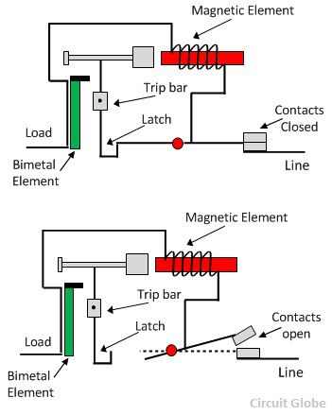
Under normal working conditions, MCB operates as a switch (manual one) to make the circuit ON or OFF. Under overload or short circuit condition, it automatically operates or trips so that current interruption takes place in the load circuit. The visual indication of this trip can be observed by automatic movement of the operating knob to OFF position. This automatic operation MCB can be obtained in two ways as we have seen in MCB construction; those are magnetic tripping and thermal tripping.
Under overload condition, the current through the bimetal causes to raise the temperature of it. The heat generated within the bimetal itself enough to cause deflection due to thermal expansion of metals. This deflection further releases the trip latch and hence contacts get separated. In some MCBs, magnetic field generated by the coil causes develop pull on bimetal such that it deflection activates the tripping mechanism.
Under short circuit or heavy overload conditions, magnetic tripping arrangement comes into the picture. Under normal working condition, the slug is held in a position by light spring because magnetic field generated by the coil is not sufficient to attract the latch. When a fault current flows, the magnetic field generated by the coil is sufficient to overcome the spring force holding slug in position. And hence slug moves and then actuate the tripping mechanism.
A combination of both magnetic and thermal tripping mechanisms are implemented in most of MCBs. In both magnetic and thermal tripping operations, an arc is formed when the contacts start separating. This arc is then forced into arc splitter plates via arc runner. These arc splitter plates are also called arc chutes where arc is formed into a series of arcs and at the same time energy extracted and cools it. Hence this arrangement achieves the arc extinction.

Earth Leakage Circuit Breaker (ELCB)
If any current leaks from any electrical installation, there must-be any insulation failure in the electrical circuit, it must be properly detected and prevented otherwise there may be a high chance of electrical shock if-anyone touches the installation. An earth leakage circuit breaker does it efficiently. Means it detects the earth leakage current and makes the power supply off by opening the associated circuit breaker. There are two types of earth leakage circuit breaker, one is voltage ELCB and other is current ELCB.

Voltage Earth Leakage Circuit Breaker
The working principle of voltage ELCB is quite simple. One terminal of the relay coil is connected to the metal body of the equipment to be protected against earth leakage and other terminal is connected to the earth directly.
If any insulation failure occurs or live phase wire touches the metal body, of the equipment, there must be a voltage difference appears across the terminal of the coil connected to the equipment body and earth. This voltage difference produces a current to flow the relay coil.
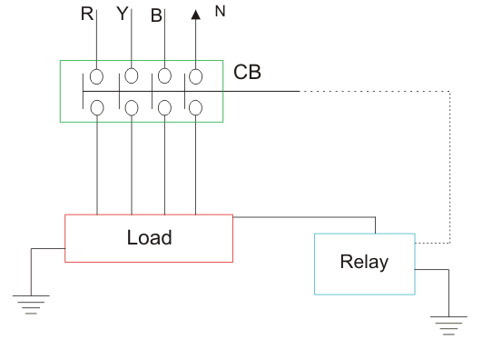
If the voltage difference crosses, a predetermined limit, the current through the relay becomes sufficient to actuate the relay for tripping the associated circuit breaker to disconnect the power supply to the equipment. The typicality of this device is, it can detect and protect only that equipment or installation with which it is attached. It cannot detect any leakage of insulation in other installation of the system.

Current ELCB or RCCB or Residual Current Circuit Breaker
The working principle of current earth leakage circuit breaker or RCCB is also very simple as voltage operated ELCB but the theory is entirely different and residual current circuit breaker is more sensitive than ELCB.
Actually, ELCBs are of two kinds, but it is general practice to refer voltage based ELCB as simple ELCB. And current based ELCB is referred as RCD or RCCB. Here one CT core is energized from both phase wise and neutral wire.
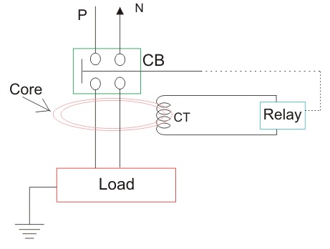
Single Phase Residual Current ELCB. The polarity of the phase winding and neutral winding on the core is so chosen that, in normal condition mmf of one winding opposes that of another. As it is assumed that, in normal operating conditions the current goes through the phase wire will be returned via neutral wire if there's no leakage in between. As both currents are same, the resultant mmf produced by these two currents is also zero-ideally. The relay coil is connected with another third winding wound on the CT core as secondary. The terminals of this winding are connected to a relay system. In normal operating condition there would not be any current circulating in the third winding as here is no flux in the core due to equal phase and neutral current. When any earth leakage occurs in the equipment, there may be part of phase current passes to the earth, through the leakage path instead of returning via mental wire. Hence the magnitude of the neutral current passing through the RCCB is not equal to phase current passing through it.

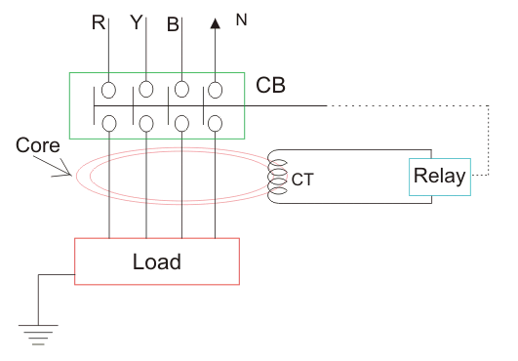

Three Phase Residual Current Circuit Breaker or Current ELCB. When this difference crosses a predetermined value, the current in the third secondary winding of the core becomes sufficiently high to actuate the electromagnetic relay attached to it. This relay causes tripping of the associated circuit breaker to disconnect the power supply to the equipment under protection. Residual current circuit breaker is sometimes also referred as residual current device (RCD) when we consider the device by disassociating the circuit breaker attached to RCCB. That means, the entire parts of RCCB except circuit breaker are referred as RCD.

Relay
Definition: The relay is the device that open or closes the contacts to cause the operation of the other electric control. It detects the intolerable or undesirable condition with an assigned area and gives the commands to the circuit breaker to disconnect the affected area. Thus protects the system from damage.

Working Principle of Relay
It works on the principle of an electromagnetic attraction. When the circuit of the relay senses the fault current, it energises the electromagnetic field which produces the temporary magnetic field.This magnetic field moves the relay armature for opening or closing the connections. The small power relay has only one contacts, and the high power relay has two contacts for opening the switch.
The inner section of the relay is shown in the figure below. It has an iron core which is wound by a control coil. The power supply is given to the coil through the contacts of the load and the control switch. The current flows through the coil produces the magnetic field around it.
Due to this magnetic field, the upper arm of the magnet attracts the lower arm. Hence close the circuit, which makes the current flow through the load. If the contact is already closed, then it moves oppositely and hence open the contacts.
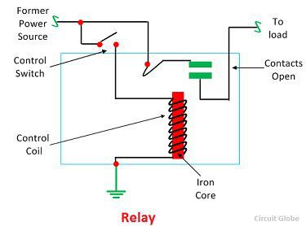

Pole and Throw
The pole and throws are the configurations of the relay, where the pole is the switch, and the throw is the number of connections. The single pole, the single throw is the simplest type of relay which has only one switch and only one possible connection. Similarly, the single pole double throw relay has a one switch and two possible connections.

Construction of Relay
The relay operates both electrically and mechanically. It consists electromagnetic and sets of contacts which perform the operation of the switching. The construction of relay is mainly classified into four groups. They are the contacts, bearings, electromechanical design, terminations and housing.
The Difference between Relay and Circuit Breaker are given below
Basis | Relay | Circuit Breaker
Principle | The Relay is a switching device which gives a signal to the circuit breaker as soon as the fault occurs in the power system. | Circuit breaker breaks the circuit automatically when receives the signal from the relay.
Working | The Relay does not break the contact. It only senses the error and send the signal to the circuit breaker. | It breaks the circuit contacts.
Type of device | The Relay is a switching and sensing device. | The Circuit breaker is an isolating or disconnecting device.
Voltage | Relays operate on low power input voltage. | The Circuit breaker is an automatic on load device
Usability | It is used to control or select one among many circuits. | It uses one per circuit.

Earthing
- Definition: The process of transferring the immediate discharge of the electrical energy directly to the earth by the help of the low resistance wire is known as the electrical earthing. The electrical earthing is done by connecting the non-current carrying part of the equipment or neutral of supply system to the ground.
- Mostly, the galvanised iron is used for the earthing. The earthing provides the simple path to the leakage current. The short circuit current of the equipment passes to the earth which has zero potential. Thus, protects the system and equipment from damage.
Types of Electrical Earthing
Neutral Earthing
- In neutral earthing, the neutral of the system is directly connected to earth by the help of the GI wire. The neutral earthing is also called the system earthing. Such type of earthing is mostly provided to the system which has star winding. For example, the neutral earthing is provided in the generator, transformer, motor etc.
Equipment Earthing
- Such type of earthing is provided to the electrical equipment. The non-current carrying part of the equipment like their metallic frame is connected to the earth by the help of the conducting wire. If any fault occurs in the apparatus, the short-circuit current passes to the earth by the help of wire. Thus, protect the system from damage.
Importance of Earthing
Following figures show the importance of earthing. In case of electrical system without earthing, fault current flows through the human body whereas in case of system with earthing it is diverted to ground/earth.

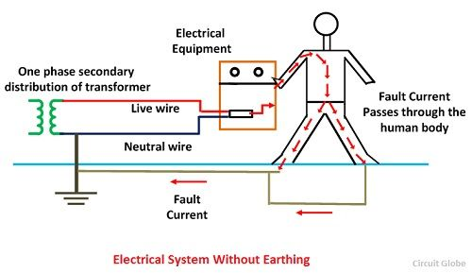
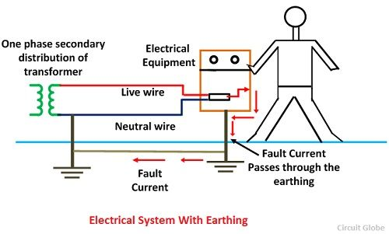

Methods of Earthing
- Earthing Mat
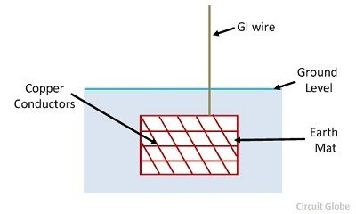
- Earthing Electrode
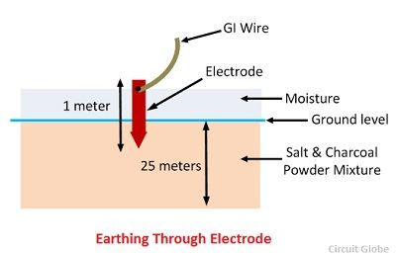

- Pipe Earthing
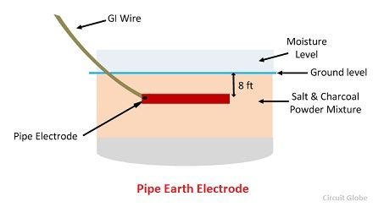
- Plate Earthing
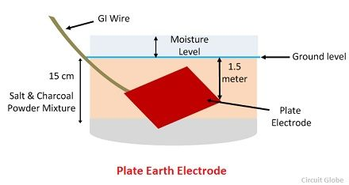

Grounding
The grounding includes measures for protecting the part of the circuit, which provides the desired function or the working feature of that circuit.
Grounding can be performed directly or indirectly. Direct grounding is carried out by direct connection of the grounding system. Indirect grounding is performed by binding to the grounding system through impedance (active resistance, inductance, capacitance, or combinations thereof).
Characteristics | Earthing | Grounding
Condition | The circuit part that does not carries current under normal condition | The circuit part that does carries current under normal condition
Protection | Protection of people and animals from an electric shock if touching | Protections of power system equipment
Wire | Generally green wire | Generally black wire
Path | Providing a path to a large surface of zero volt potential | Providing a return path to the current in case of faulty/abnormal conditions.
Difference betweenEarthing and Grounding
ELECTRICAL HAZARDS
- SHOCK. Electric shock occurs when the human body becomes part of the path through which current flows.
- BURNS. Burns can result when a person touches electrical wiring or equipment that is energized.
- ARC-BLAST. Arc-blasts occur from high- amperage currents arcing through the air. This can be caused by accidental contact with energized components or equipment failure.
- EXPLOSIONS. Explosions occur when electricity provides a source of ignition for an explosive mixture in the atmosphere.
- FIRES. Electricity is one of the most common causes of fires both in the home and in the workplace. Defective or misused electrical equipment is a major cause.

Safety Precautions while working with Electricity

It is necessary to observe safety precautions while using the electric supply to avoid the serious problems like shocks and fire hazards. Some of the safety precautions are listed below:
- Insulation of the conductors used must be proper and in good condition.
- Periodically Megger tests should be conducted and insulation must be checked.
- Earth connection should be always maintained in proper condition.
- Make the mains supply switch off and remove the fuses before starting work with any electrical installations.
- Fuses and circuit breakers must have correct ratings
- Use dry rubber soled shoes while working.
- Use rubber gloves while touching any terminals or removing insulation layer from a conductor
- Use a line tester to check whether a live terminal carries any current still better method is to use a test lamp.
- Always use insulated screw drivers, pliers, line testers etc.
- Never touch two different terminals at the same time.
- Never remove the plug by pulling the wires connected to it
- The sockets should be fixed at a height beyond the reach of the children.
- Never touch the switch, sockets and any other electrical appliance with wet hand.
- For more sensitive equipment, use RCCB or ELCB

